Importation of untanned animal hides from Colombia in 2012–13
Interim Inspector-General of Biosecurity
Incident review report
February 2014

No. 2013–14/4
Contents
Glossary iii
Summary 1
Context 1
Review objectives 2
Review scope 2
Key findings 2
Recommendations 8
Introduction 10
1. Background 10
2. The incident 10
3. Methodology 14
Observations and findings 16
4. Departmental controls and procedures 16
5. Incident findings 21
6. Biosecurity risks 30
Appendix A: Department response 32
Appendix B: Conduct of the review 37
Appendix C: Chronology of events 39
Appendix D: Photographs 40
Appendix E: Relevant Australian legislation 42
Appendix F: Agencies, groups and individuals consulted by the Interim Inspector-General of Biosecurity 45
References 46

Glossary
acid pickling | Method of preparing hides and skins for tanning or long-term storage by using acids and salts to achieve pH 4 or lower; pH is a measure of acidity or alkalinity—solutions with a pH of less than seven are acidic.
AQIS Import Management System (AIMS) | Managed by the Department of Agriculture, AIMS retains records of quarantine entries for goods entering Australia. It provides quarantine management of imported goods and non-commodity items, records the department’s decision-making process and communicates this information to the importer/broker. AIMS is used to:  - manage biosecurity and food safety risks associated with imported cargo  - track and record imported consignments  - assign departmental fees and collect revenue on imported cargo.
Beale review | Independent review of Australia’s quarantine and biosecurity arrangements by a panel chaired by Mr Roger Beale AO. The report One biosecurity: a working partnership was released by the Australian Government on 18 December 2008.
biosecurity risk | Potential harm to the economy, environment and human health from the negative impacts associated with entry, establishment or spread of exotic pests and diseases.
crust | Leather which has been tanned but not finished.
de-hairing | Process of removing hair from hides by the use of sulphides and a high pH, usually between 12.6 and 13.2. De-hairing and liming are normally done as a single process.
de-liming | Part of the tanning process that returns hides and skins to a neutral pH after liming.
fully processed hides and skins | Hides and skins that have undergone both liming and acid pickling; includes fully tanned hides and skins, wet whites and wet blues.
Import Conditions (ICON) database | Manages and makes publicly available Australian quarantine import conditions for more than 20 000 plant, animal, mineral and human commodities. ICON is managed by the Department of Agriculture and specifies the documentation requirements for the clearance process.
ICON permits database | Used by department officers to verify import permits before processing an entry.
import risk analysis (IRA) | Process enables the Australian Government to formally consider risks associated with proposals to import new products into Australia. IRAs are undertaken by the department.
Integrated Cargo System (ICS) | Software application for all import and export reporting and processing procedures. The only method of electronically reporting legitimate movement of goods across Australia’s borders, ICS is managed by the Australian Customs and Border Protection Service.
leather | Fully tanned hides and skins.
lime split /split | Liming loosens collagen fibres allowing skin to be sliced in layers to give uniform thickness to the piece (grainside). Split leather (inside) is trimmed and finished as suede.
liming | Process of using an alkaline medium to loosen cross linkages between collagen fibres to enable tanning salts to enter the tissue, and at the same time raise the pH throughout the thickness of the skin.
minimum document requirements policy | Defines minimum requirements that must be met for all documents presented to the department to support risk assessment of imported cargo and/or packaging, whether for quarantine or food safety purposes.
partially processed hides and skins | Hides and skins that have undergone a liming process or acid pickling, but not both.
quarantine approved premises (QAP) | Place approved by the department under section 46A of the Quarantine Act 1908 as a place where goods of a specified class that are subject to quarantine may be treated or otherwise dealt with.
raw hides and skins | Hides and skins that have not undergone processing beyond drying or salting.
risk management | Identification, documentation and implementation of measures to reduce the risks and consequences (for example by using the World Organisation for Animal Health International Animal Health Code).
standard operating procedures (SOP) | Document that outlines procedures for conducting significant operational activities, taking into account management of risk, legislation and occupational health and safety requirements.
tanning | Process that strengthens the cross linkage bonds between collagen fibres and causes the fibres to become resistant to decay or deterioration.
unprocessed hides and skins | Hides and skins that have not undergone liming or acid pickling.
untanned hides and skins | Hides and skins that have had no processing or that are partially processed but not tanned.
wet blues | Hides and skins that have been limed, pickled and lightly or fully chrome tanned but not dried. Wet blue hides and skins are considered by the department to be fully processed.
wet whites | Alum sulphate pre-tanned hides and skins that have been limed and pickled. Wet white hides and skins are considered by the department to be fully processed.
work instruction | Comprehensive, easy-to-understand document that complements a SOP and provides definitive guidance to department staff for performing specific operational tasks.

Summary

Context
- The annual work program for the Interim Inspector-General of Biosecurity (IIGB) includes provision for high priority activities, such as ad hoc requests from the minister and other key stakeholders.
- On 8 July 2013 the former Minister for Agriculture, Fisheries and Forestry sought independent advice from the IIGB about the importation of untanned animal hides from Colombia. This request was not formalised due to the announcement of the federal election and commencement of the caretaker period. However, given the biosecurity risks involved, the IIGB decided to initiate this incident review immediately.
- The Quarantine Act 1908 governs, inter alia, importation of biological material (including hides and skins) into Australia. Risk management measures to minimise biosecurity risks for Australia are implemented by the Department of Agriculture (department) under the Quarantine Act 1908 and subordinate legislation, such as the Quarantine Proclamation 1998. The biosecurity risks represented by animal hides can be broadly categorised as negligible for fully tanned; very low to low for untanned limed or acid pickled depending on pests and diseases in the country of export; and low to high for raw/fresh also depending on pests and diseases occurring in the country of export.
- This IIGB incident review focuses on biosecurity matters; other agencies may be investigating this incident for other purposes.
- On 16 May 2013 the department received information from a cold store owner (Quarantine Approved Premises (QAP) operator) in Sydney about animal hides that had been stored at the facility since September 2012. The owner was concerned that the hides, which had been imported from Colombia, did not appear to be fully tanned and might therefore pose a biosecurity risk (The incident is described in detail in section 2 of this report).
- Department records showed seven consignments of animal hides or skins (either raw, untanned or partially tanned), weighing a total of around 85 tonnes, were imported from Colombia by the same importer between 2 May 2012 and 7 January 2013. The consignments (in nine temperature controlled containers) were imported through Port Botany, New South Wales.
- The department regulates entry of untanned animal hides and skins through an import permit system that specifies requirements that must be met for untanned hides and skins to enter Australia. By contrast, tanned animals hides and skins do not require an import permit and can be imported from any country. Both untanned and tanned animal hides and skins are subject to specific import conditions.
- Animal hides and skins have been imported into Australia for several decades, as indicated by Quarantine regulations and administrative instructions in the 1980s. Fifty-nine countries exported untanned and tanned animal hides and skins to Australia from 1 January 2008 to 31 October 2013; of the 1577 consignments, 620 were raw or untanned and 959 were tanned.

Review objectives
- The review objectives were to examine:
- factors that led to the clearance and release of untanned animal hides imported from Colombia between May 2012 and January 2013
- factors that led to detection of these consignments of untanned animal hides
- biosecurity risks associated with these consignments
- whether improvements are required to import procedures and operations in order to reduce such biosecurity risks in the future.

Review scope
- The IIGB’s review also examined the department’s border procedures and operations for the importation of animal hides, including:
- application of import conditions and permits
- verification of certifications and declarations
- processes relating to inspection, verification and reporting activities at the border
- biosecurity risks associated with imported animal hides
- any improvements required to policies and operations in order to reduce the likely recurrence of such biosecurity incidents.

Key findings
Import documentation
- The IIGB noted that when the department became aware of the hides, department officers made repeated requests for the relevant documentation from the importer/broker. Despite the department’s efforts, the import documentation was not provided for almost a month. The delay in receiving the import documents hindered the investigation and caused undue tension with third parties involved. The IIGB cannot confirm whether the import documentation received as part of this review is the same as that originally presented at the front counter at the time of import, as copies were not retained by the department. The IIGB believes that it would be beneficial if all import documents were retained and archived electronically, especially in situations where queries or issues might arise.
- For each of the seven consignments, the importer/broker correctly declared the hides in the Customs Integrated Cargo System (ICS) as raw hides and skins of bovine origin (tariff code 4101) and the consignments were correctly referred from the ICS to the department’s import management system (AIMS) for further biosecurity assessment. As part of the presentation of the documents that were assessed, there were discrepancies between the tariff description (untanned) and the manufacturer’s declarations submitted to department officers. The department then cleared and released the hides as being tanned. Goods declared under code 4101 are required to have an import permit; presentation of the permit and verification that permit conditions have been met, are an essential part of the clearance process.
- All consignments were cleared for entry because they were accompanied by documentation (manufacturer’s declarations) stating that the hides were fully tanned; consequently all the consignments were cleared for entry without undergoing a physical inspection. The goods as declared in ICS were subject to an import permit and in this situation, a manufacturer’s declaration is not a valid document for clearance purposes.
- Each of the seven consignments was cleared by a different department officer. Documentation for each consignment was presented in person at the time of importation, at the Sydney regional office. These circumstances would dispel any concerns regarding possible collusion between the importer/broker and a department officer(s).
- The importer/broker provided documentation that included inconsistent descriptions of the hides as either ‘fully tanned’ or ‘lime split’. For all consignments, a manufacturer’s declaration was provided, stating that the hides were fully tanned. This false information may have been provided to facilitate clearance of the hides. The heavy reliance on manufacturers’ declarations must be questioned.
- The need for effective communication with industry stakeholders should also be recognised. The department has an on-going responsibility, and challenge, to explain the biosecurity risks associated with various categories of hides, and the importance of correct ICS declarations.
- Given the number of discrepancies in the documentation and non-compliance with the department’s minimum document requirements policy (DAFF 2012), the IIGB believes that these consignments should not have been released on the basis of documentation alone. The IIGB was not able to ascertain whether the importer/broker pressured various officers at the department’s front counter to clear the consignments, nor which documents were originally presented. However, it does appear that entry management officers, particularly at the front counter, were looking for at least one key document in order to clear and release the goods; in this case it was the manufacturer’s declaration stating that the hides were fully tanned.
- Notwithstanding the inappropriate decisions made for each of the seven consignments, no fault or blame should be attributed to the individual department officers at the front counter. Rather, the faults appear to lie within the entry management process and related training programs.
- It appears that the department officers cleared the goods as tanned hides because they did not understand or consider why the goods had been referred through to the department. The IIGB has been advised that changes are planned in the import management system to ensure that referral information, including reasons why the entry has been referred to the department, is prominently displayed initially whenever an entry is accessed. This will provide officers with vital information and help them accurately assess each entry.
Entry Management Program
- The Entry Management Program is a cost recovered program, which is delivered by regional based management and teams. The application of entry management, depending on the region, can appear to focus on meeting targets and processing entries as quickly as possible, with possibly less emphasis on biosecurity risk.
- The IIGB believes that the department’s entry management procedures could be improved by moving the processing and assessment of all documentation to the back office, away from the front counter. This change could also facilitate adoption of a triage system, where complex or high-risk entries could be referred to more experienced staff.
- The Entry Management Program has a comprehensive staff training component. Staff are assessed on their progress and allocated a skill rating. The IIGB was informed that the seven officers responsible for clearing these consignments were deemed sufficiently skilled under the department’s requirements to process entry/clearance documents independently. However, the incorrect decisions made by the seven officers over an extended period of time highlight the importance of enhancing and improving the training program.
- The IIGB believes that the training program could be strengthened, to improve an officer’s decision-making capability and to emphasise the importance of quality assessments. It is important to teach problem-solving and encourage officers to seek clarification in any questionable or complex situation. Further training should be provided to entry management officers, to assist with situations that arise where the entry information appears to be contradictory or inconsistent. It is noted that the training package for operational staff is now being enhanced and updated, placing greater emphasis on risk assessment.
- The IIGB believes that the Entry Management Program should also implement an additional quality assurance program, where random checks are undertaken to confirm that officers are clearing goods appropriately. This would help identify inappropriate clearances and benefit the staff learning and development process. The IIGB understands that the department’s new Priority Processing System is being implemented in April 2014 and will include a verification process which should address this issue.
Profiling enhancements
- The IIGB noted that all seven consignments were transported to Australia in refrigerated containers that were temperature controlled. Profiling could be enhanced to identify where the method of transport appears to be inconsistent with the commodity being imported. At the same time, it should be acknowledged that many refrigerated containers are shipped to Australia, containing general cargo and not as temperature-controlled units, to re-locate the containers for the subsequent export of refrigerated cargo from Australia.
- The IIGB also believes that it would be beneficial for a first-time supplier/exporter who is importing hides and skins into Australia to have their initial consignment inspected, to ensure that the hides and skins have been processed appropriately. This would also be valuable for other high-risk commodities being imported into Australia.
Import risk analysis for hides and skins
- The department’s import risk analysis for hides and skins was developed in November 2002. This comprehensive and useful reference document has been used by the department to assess import applications for hides and skins. The IIGB noted that in light of this incident this document and relevant policies are being reviewed and a guidance document for the quarantine assessment of hides and skins is being prepared as part of this review. It is recommended that the revised import requirements be finalised and published on the department’s website as soon as possible.
Departmental operating procedures
- The department has a set of standard operating procedures and work instructions that departmental officers follow when assessing import permit applications, undertaking the entry management process, post border quarantine detections and the management of quarantine approved premises. The IIGB noted that, in relation to this incident, internal communications with department staff about standard operating procedures and work instructions were clear and adequate.
- Once the department became aware of the hides, the seizure and disposal of the hides were undertaken in accordance with approved procedures. The IIGB acknowledges the considerable efforts made by the department to trace all consignments and appropriately manage the biosecurity risks. However, it was noted that the hides were transported once in a tautliner truck, not in a refrigerated truck. (see Photograph D3 that shows the tautliner truck, Appendix D)
- The guidelines for post-border recovery operations stipulate that where goods are being moved, they must be transported in the same condition as they are stored. This ensures that their integrity is maintained. Therefore the appropriate transport method would have been a refrigerated truck.
- The IIGB was informed that a refrigerated truck was not available to move the hides. The Border Compliance Division in Canberra undertook a risk assessment and determined that it would be satisfactory to move the hides on a tautliner truck. The risk assessment took account of the temperature on the day and the travel distance.
Biosecurity risks
- This investigation undertaken by the IIGB is not an import risk analysis. This review is an assessment of possible risks associated with an incident of untanned (partially processed) hides that had already arrived in Australia. Untanned hides and skins have significantly different biosecurity risks to equivalent tanned products and therefore different import requirements.
- The hides in this incident were imported from Colombia and were of bovine origin. The tanning experts who examined the hides believed that they were in a partially processed, de-haired, limed state. The tanning experts confirmed that the hides were not fully tanned.
- The IIGB noted that before hides are tanned, they are de-haired; this involves the use of lime at a pH of between approximately 12.3 and 13.2 (Harkness 1991), which inactivates most significant animal pathogens.
- Concern was expressed by the cold store owner and others to the IIGB that blood and/or serum was present on the hides and leaking from the bags that contained the hides. Based on firsthand examination of hides from several consignments, together with detailed discussions with two experienced tanning experts and an internationally recognised forensic science expert, the IIGB has concluded that fluid observed on or around the bags of hides posed no significant biosecurity risk. Any fluid seen leaking from the thawed hides and/or bags was probably condensate (mainly water) that may have possibly been stained by the wooden pallets used for storage and transport, and/or rusting metal.
- Photographs of the hides, bags, pallets and surrounding floor areas were taken by the IIGB and also provided by department officers and other sources. These photographs were examined by the forensic expert, who confirmed that the amount of blood present (if any) did not appear to be significant enough to create any biosecurity risk in terms of potential disease transmission, in this particular case. However, the need to report any suspicious detection of blood or similar fluids in imported cargo remains of critical importance.
Conclusion
- All stakeholders play an important role in the management of national biosecurity risks. The department often relies on community and industry stakeholders to inform them of any biosecurity concerns. In this case, action by a vigilant cold store owner (fulfilling the responsibilities of a QAP operator) led to the seizure and appropriate destruction of most of the imported hides.
- The department has implemented a ‘risk return’ approach to managing biosecurity risks; this places greater emphasis on compliance and focuses inspection activity on those goods and entities that are assessed as being of highest risk. Given that certain untanned hides are considered to be a high-risk commodity, subject to import permit requirements, these particular consignments were not managed appropriately.
- The IIGB appreciates that the department’s Entry Management processing and clearance area can be a challenging and high pressure work environment. The work is varied and requires considerable knowledge across many commodities; each case also requires an officer’s focus and detailed attention. However, given the number of inconsistencies in the documentation and non-compliance with the department’s minimum document requirements policy, the IIGB believes that these consignments should not have been released on the basis of documentation alone. It appears that the underlying fault lies within the entry management process and related training programs.
- These imported bovine hides had undergone a liming process and had been exposed to high pH levels for a prolonged period. The IIGB believes that these factors substantially reduced the risks of foot and mouth disease and anthrax, as well as other pathogens. It is important that inspection staff can differentiate, both visually and on documentation, high risk raw/fresh hides and skins from the lower risk limed or acid pickled product and appropriate post arrival measures applied.
- This incident highlights the importance of balancing sustainable cost recovery strategies against the department’s ability to effectively manage biosecurity risks. International trade is increasing and anticipated budget cuts could see reduced numbers of front-line biosecurity officers. For these reasons, the department is enhancing intelligent, predictive profiling solutions to aid the effective management of biosecurity risks.
- In a tough challenging economic environment, and with finite departmental resources, the IIGB recognises that it is beneficial to address national biosecurity risks in different and smarter ways by:
- maximising use of modern technology
- identifying and targeting high-risk consignments through the use of improved intelligence (on-shore and off-shore) and a full understanding of the whole supply chain
- strengthening relationships with industry—closer collaboration with compliant industry stakeholders and performance-based interventions
- maintaining and improving the quality of the department’s workforce, with strong leadership, training and enhancement of technical expertise (investment in people)
- streamlining of national service delivery arrangements
- effective communication with all parties across the biosecurity continuum and the Australian community.
- While the department is working on several fronts to address these challenges, it is important that the lessons learned from this incident are acknowledged and used to best effect, to strengthen national biosecurity arrangements.

[Signed]

Dr Michael Bond
Interim Inspector-General of Biosecurity
20 February 2014

Recommendations
The full department response to the recommendations is at appendix A.
Recommendation 1
paragraph 4.9 | The department should finalise its review and release to the public (as soon as practicable) the import requirements for hides and skins.  Department’s response: Agrees.
Recommendation 2
paragraph 4.32 | New or revised departmental guidelines, standard operating procedures and work instructions should be communicated, published and available to staff in a timely manner.  Department’s response: Agrees.
Recommendation 3
paragraph 5.4 | The department should investigate the possibility of retaining and archiving electronic copies of all import documents used in the clearance process, including those presented at the front counter.  Department’s response: Agrees in principle.
Recommendation 4
paragraph 5.14 | The department should explore options to ensure that any manufacturers’ declarations used in the clearance process are authentic.  Department’s response: Agrees.
Recommendation 5
paragraph 5.19 | The department should consider providing incentives to encourage the further uptake of the electronic lodgement of entries and accurate declarations.  Department’s response: Agrees in principle.
Recommendation 6
paragraph 5.22 | The department should continue to move processing and assessment of all import documentation to the back office, away from the front counter. This would facilitate adoption of a triage system, where complex entries are referred to more experienced staff.  Department’s response: Agrees.

Recommendation 7
paragraph 5.25 | The Entry Management training program should be enhanced to improve decision-making capabilities; this incident can be used as a case study to demonstrate the lessons learned, especially in relation to inconsistencies in documentation.  Department’s response: Agrees.
Recommendation 8
paragraph 5.27 | The department should consider implementing an additional quality assurance system, where regular random checks are undertaken to confirm that officers are clearing goods appropriately.  Department’s response: Agrees.
Recommendation 9
paragraph 5.33 | In any future review of the department’s staff mobility policy, a rigorous risk assessment should be undertaken to determine the level of expertise required for the Entry Management Program.  Department’s response: Agrees.
Recommendation 10
paragraph 5.43 | The department should develop a specific assessment regime for first-time importers of untanned hides and skins, to ensure that the goods have been processed according to import requirements.  Department’s response: Agrees.

Introduction
- Background
  - The annual work program for the Interim Inspector-General of Biosecurity (IIGB) includes provision for high priority activities, such as ad hoc requests from the minister and other key stakeholders.
  - On 8 July 2013 the former Minister for Agriculture, Fisheries and Forestry sought independent advice from the IIGB about the importation of untanned animal hides from Colombia. The former minister did not formalise the request due to the announcement of the federal election and commencement of the caretaker period. In these circumstances, considering the potential biosecurity risks involved, the IIGB decided to initiate a review of this incident immediately.
  - Untanned and tanned hides were exported to Australia from fifty-nine countries between 1 January 2008 and 31 October 2013. Table 1 shows the number of consignments of untanned and tanned hides and skins imported into Australia during this period.
Table 1 Consignments of untanned and tanned hides and skins, 2008–13
Tariff code | 2008 | 2009 | 2010 | 2011 | 2012 | 2013 | Total consignments
4101 a | 95 | 60 | 88 | 117 | 106 | 154 | 620
4104 b | 221 | 130 | 152 | 163 | 172 | 121 | 959
Notes: a Raw hides and skins of bovine (including buffalo) or equine animals (fresh or salted, dried, limed, pickled or otherwise preserved, but not tanned, parchment dressed or further prepared), whether or not de-haired or split. b Tanned or crust hides and skins of bovine (including buffalo) or equine animals, without hair on, whether or not split, but not further prepared.
Source: AIMS 2014
  - The department’s information management system (AIMS) records consignment quantities in several ways, including as kilograms, pounds or number of items. Consequently, it is not possible to report on the total quantities of untanned and tanned hides imported into Australia.
  - From 1 January 2008 to 31 October 2013, 1577 (two consignments had items belonging to both tariff codes) consignments of tanned and untanned hides and skins were imported into Australia, of which 620 were raw or untanned and 959 were tanned. Quarantine regulations and administrative instructions from the 1980s also indicate a long history of importing untanned and tanned hides and skins into Australia.
- The incident
  - On 16 May 2013 the owner of a quarantine approved premises (QAP 1) that is a cold store in Sydney contacted the department about 20 bags of animal hides that had been stored at the facility since September 2012. They were directed by the importer/broker to be stored under temperature control. The owner was concerned that the imported hides from Colombia appeared to be not fully tanned, and might therefore pose a biosecurity risk. The owner also expressed concern about possible health and safety risks to staff. On the same day a department officer attended the cold store to inspect the hides. The cold store owner had thawed a number of hides to check their condition and to facilitate inspection. After inspection, the officer ordered the hides into quarantine and issued the owner with the relevant paperwork.
  - Department records showed that seven consignments of animal hides, weighing a total of around 85 tonnes, were imported from Colombia by the same importer/broker between 2 May 2012 and 7 January 2013. The consignments (in nine temperature-controlled containers) were imported through Port Botany, New South Wales.
  - All consignments were declared as untanned hides (tariff code 4101) and required a valid import permit, but were cleared for entry because they were accompanied by documentation (manufacturer’s declarations) stating that the hides were fully tanned (tariff code 4104 does not require a permit); consequently the consignments were cleared for entry without being physically inspected.
  - The documentation for each consignment was presented in person at the time of importation, at the Sydney regional office front counter; this documentation was inconsistent with requirements for the declared tariff code 4101. When documentation is presented in person, copies are not retained by the department. Documentation is only kept and archived by the department if it is submitted electronically.
  - Under section 16AD of the Quarantine Act 1908, department officers can request the importer/broker to provide additional information. Brokers are required to retain documentation used for decision making for a period of 18 months under the requirements of the department’s broker schemes. Under the Customs Act 1901, an importer is required to keep all relevant commercial documentation for five years; an importer must be allowed at least 14 days to produce any retrospective documentation.
  - On 20 May 2013 the department requested relevant documentation from the importer/broker for the one consignment that had been ordered into quarantine on 16 May 2013. On 23 May 2013 the department requested further documentation for the other six consignments of animal hides that were imported from Colombia.
  - The department subsequently made numerous requests for the required documentation for all the consignments. The department eventually received the import documentation from the importer/broker after business hours on Friday 14 June 2013.
  - Following further discussions with the importer/broker, on 20 June 2013 the department located four containers linked to the other six consignments at another quarantine approved premises in Sydney (QAP 2). Ten bags of non-containerised hides were also inspected at the site. All the identified Colombian hides were ordered into quarantine. Goods ordered into quarantine cannot be moved or destroyed without approval and authorisation from the department.
  - On 25 June 2013 department officers attended the QAP 2 premises where the four containers were located. The officers inspected each container and accounted for 105 bags of hides. A total of 115 bags of hides were located at QAP 2, which included the ten bags of non-containerised hides that were inspected at the site on the 20 June 2013.
  - At the request of the department, on 25 June 2013 samples of the hides were inspected by a tanning expert who concluded that the hides were only limed and not fully tanned. The expert provided a written report to the department on 2 July 2013.
  - On 17 July 2013 the department formally seized 135 of the 180 bags of animal hides that were reported as being imported—20 bags from QAP 1 and 115 bags from QAP 2. Goods seized under the Quarantine Act 1908 are forfeited to the Commonwealth and from the time of seizure, the animal hides become the department’s responsibility. The department is also then responsible for costs associated with the goods, such as storage fees, transport and destruction costs.
  - On 19 July 2013 the department moved the 20 bags of animal hides from the QAP 1 where they were originally stored to QAP 2 where the other four consignments were being stored. This consolidated all the seized animal hides at one location.
  - Between 26 July 2013 and 14 August 2013 the seized hides were transported under supervision to an approved treatment provider in Sydney and incinerated. As this company is an approved treatment provider, the department was satisfied with their business operations, biosecurity management and security arrangements. As each container was opened, one bag was labelled and placed in a secure area to allow for thawing so that the department could take samples for possible use as evidence.
  - The department received notification on 28 August 2013 that all hides had been destroyed. Destruction of the 135 bags cost the department $114 051.19 (including storage, transport and cleaning).
  - The IIGB acknowledges the considerable efforts made by the department to trace all consignments and appropriately manage the biosecurity risks.
  - Appendix C outlines the sequence of events in this incident.
Tracking consignments
  - Table 2 outlines information on the seven consignments.
Table 2 Consignment information, 2012–13
Description | Cnsgt 1  5 May 2012 | Cnsgt 2  18 Aug. 2012 | Cnsgt 3  31 Aug. 2012 | Cnsgt 4  29 Sept. 2012 | Cnsgt 5  12 Oct. 2012 | Cnsgt 6  11 Dec. 2012 | Cnsgt 7  12 Jan. 2013 | Total
Bill of lading – bags | 20 | 20 | 20 | 20 | 20 | 40 | 40 | 180
Bill of lading – weight (kg) | 5 880 a | 11 600 | 9 120 | 9 930 | 9 517 | 20 525 | 19 261 | 85 833
Bags inspected and seized by the department | 0 | 20 | 20 | 15 | 0 | 40 | 40 | 135
Bags not accounted for | 20 | 0 | 0 | 5 | 20 | 0 | 0 | 45 b
Note: a The weight for consignment one was recorded as KGM. b One bag from consignment one was sent to a tanning expert in Victoria by the importer/broker and later disposed of at a landfill site in Victoria. The IIGB was informed that 39 bags (from the first and fifth consignments) were disposed of at a waste facility in Sydney. The fourth consignment of 20 bags was directed to QAP 2. The container was inspected by the department and only 15 bags were recovered. It is unclear where the remaining five bags are or whether they were ever imported into Australia. Cnsgt: Consignment
Source: IIGB 2013
  - The importer/broker sent one bag from consignment 1 to a tanning expert in Victoria in June 2012 to determine whether the hides could be used and whether they had any commercial value. The tanning expert explained that the hides had little or no commercial value, were deteriorating and in the process of turning gelatinous. The importer/broker then instructed the tanning expert to dispose of the hides. They were placed in an uncovered skip bin at the tannery where they remained for several months until the bin was collected on 5 March 2013 and eventually emptied at a rural landfill site in Victoria. The IIGB was informed that the bag of hides is buried under 20 metres of landfill.
  - The importer/broker advised the department that 40 bags comprising consignment 1 and 5 were disposed of by the importer/broker at a waste facility in Sydney. The importer/broker also advised that the fourth consignment of 20 bags was directed to QAP 2 (where four other containers were located). The container was inspected by the department and only 15 bags were recovered. It is unclear where the remaining five bags are or whether they were ever imported into Australia.
  - The waste facility in Sydney where the importer/broker disposed of two consignments provided information on the quantity of hides disposed of. However, the IIGB was unable to reconcile the quantities because of the disparity in weights recorded.
  - Figure 1 outlines movements for each consignment and actions taken by the importer/broker and the department.
Figure 1 Consignment movements and events after importation, 2012–13
Note: The IIGB was informed that the hides directed for destruction were incinerated over a period of about four weeks. The department received notification on 28 August 2013 that all 135 bags of hides had been incinerated. The five bags unaccounted for in the fourth consignment is explained at section 2.19
Source: IIGB 2013
- Methodology
  - The methodology for this review included:
- an entry meeting with stakeholders to enable the IIGB to
  - communicate review objectives and scope
  - outline responsibilities
  - identify risks to the review and any appropriate mitigation strategies
  - request background information to assist the review process
  - provide an opportunity for all parties to discuss the review and seek points of clarification from the IIGB about the proposed review process
- a desktop review of relevant departmental documentation and information (for example, standard operating procedures, work instructions, permits, certificates, and communications material) and inspection and verification procedures at the border
- discussions with relevant department staff to understand work already undertaken in reviewing the circumstances of this incident and any remedial action already taken
- fieldwork to assess procedures and operations of the department at the border
- interviews with interested parties and relevant experts to obtain additional information, opinions and advice
- exit interviews with stakeholders to
  - provide an overview of initial findings and observations
  - provide an opportunity for stakeholders to correct any misunderstandings or errors and provide feedback on the review process
  - outline the process for release of and response to the draft report
- the development of the draft report with key findings and recommendations
- a ‘fact check’ of the draft report by the department to correct any misunderstandings or errors, and to provide further feedback on the review process
- finalisation of the draft report and provision to the Secretary, seeking formal management comments from the department
- development of the final report and provision to the minister with formal management comments
- the minister’s approval (or not) to publish the final report on the department’s website.
  - The agencies and groups consulted by the IIGB as part of this review are listed at Appendix F.
Out of scope
  - This review did not examine:
- broad government policy relating to importation of animal hides
- international trade aspects
- commercial considerations or possible criminal activities
- post-border surveillance activities undertaken by state or territory authorities.

Observations and findings
- Departmental controls and procedures
Legislative controls
  - The Quarantine Act 1908 regulates, inter alia, the importation of hides and skins into Australia. The department is responsible for administering this legislation.
Quarantine Act 1908
  - The Quarantine Act 1908 provides powers in relation to animals, plants or other goods to prevent or control the introduction, establishment or spread of disease or pests that could cause significant damage to humans, animals, plants, the environment or the Australian economy. A key risk management measure to minimise biosecurity risks to Australia is contained in this Act through the power vested in the Governor-General to prohibit, by proclamation, the introduction or importation of certain goods into Australia.
  - The relevant proclamation helps the department assess the risk associated with the importation of hides and skins and implement appropriate risk management measures to control the associated risks. These measures are managed, in part, by the department through the import permit process.
  - Section 38 of the Quarantine Proclamation 1998 is applicable to hides and skins.
  - Regulation 70 of Quarantine Regulations 2000 sets out the requirement for an application for an import permit to import hides and skins. Section 70 of the Quarantine Proclamation 1998 and section 34 in both the Quarantine (Cocos Islands) Proclamation 2004 and the Quarantine (Christmas Island) Proclamation 2004 state how the power to grant a permit is to be exercised.
  - Appendix E lists some key provisions of the Quarantine Act 1908 and the Quarantine Proclamation 1998.
Import risk analysis
  - In November 2002 the department prepared an import risk analysis for hides and skins, incorporating biosecurity risks and elements of Animal Biosecurity policies developed in 2000. The department uses this comprehensive document to assess import applications for hides and skins. The IIGB noted that, as a result of this incident, the department is reviewing this document and relevant policies and is preparing a guidance document for the biosecurity assessment of import applications. It is recommended that the import requirements be finalised and published as soon as practicable.
  - The department’s Animal Biosecurity Branch provides policy and guidance based on the 2002 import risk analysis to the Biological Import Program to help assess import permit applications. While fully tanned hides and skins do not require an import permit, untanned or partially tanned hides and skins do.
Recommendation 1
  - The department should finalise its review and release to the public (as soon as practicable) the import requirements for hides and skins.

Department’s response:
The department agrees with this recommendation. A comprehensive scientific review is underway of the import conditions for animal hides and skins. The department anticipates release of the review by 30 June 2014.
Import permits
  - The department’s biosecurity import controls are set out in the import conditions database (ICON). ICON specifies the import conditions that cover risk management measures for more than 20 000 plant, animal, mineral and human products. ICON provides information to department officers and the public on import processes and conditions for specific commodities.
  - Untanned and tanned imported hides and skins are products with significantly different biosecurity risks and therefore different import requirements. The different requirements for untanned and tanned hides and skins are outlined in sections 4.13 to 4.22. The department regulates entry of untanned hides through an import permit system that specifies requirements that must be met in order for untanned hides and skins to enter Australia. By contrast, eligible tanned hides and skins can be imported from any country and released after the department has verified that satisfactory documentation has been presented at the border.
Untanned hides and skins
  - Importation of untanned hides and skins requires an import permit that must be valid at the time the goods are imported. Untanned hides and skins can be imported from any country; however, different import conditions apply to Fiji, New Caledonia, New Zealand, Norfolk Island, Papua New Guinea, Western Samoa, Solomon Islands, Tonga and the Kingdom of Vanuatu based on historical requirements under the now repealed Quarantine Regulations (Animal).
  - Depending on the species and country of origin, treatment may be required before importation. Under import permit conditions hides and skins may also be directed for tanning at a quarantine approved premises (QAP Class 3.0) on arrival in Australia. This site must be approved under section 46A of the Quarantine Act 1908. Once the hides and skins have been fully tanned they may be released from quarantine.
  - All consignments of untanned hides and skins are inspected on arrival to confirm that the goods are as listed on the import permit and to ensure freedom from contamination and/or infestation by extraneous materials.
  - Import permits are granted on the basis that untanned hides and skins will not be used in animal foods, fertilisers or for growing purposes.
  - Table 3 shows the number of permits granted for untanned hides and skins annually, from 1 January 2009 to 31 August 2013.

Table 3 Import permits issued for untanned hides and skins, 2009–13
Year | Permits issued
2009 | 97
2010 | 102
2011 | 97
2012 | 99
2013 (to 31 August 2013) | 53
Total | 448
Source: ICON 2013
  - The department issued 448 permits for untanned hides and skins from 1 January 2009 to 31 August 2013. This includes permits for partially treated hides and skins. As at 31 August 2013, 190 of these permits were still valid.
  - Permits issued for countries and importers reflect the disease status of each country and any prior treatments will reflect the conditions placed on the permit. Permits can be valid for a one-off consignment or for a maximum of two years for multiple consignments.
Tanned hides and skins
  - Importation of hides and skins that have been fully tanned (with or without hair) are not of quarantine concern, because the tanning process is sufficiently rigorous to destroy diseases or pests in the hide and skin. Fully tanned hides and skins can be imported from any country and do not require an import permit.
  - Consignments of tanned hides and skins must be accompanied by documentation that describes the tanning or processing applied to the hides and skins. Documentation to confirm that the goods are tanned is not required if the goods are highly processed, for example in products such as leather furniture or apparel.
  - Consignments of tanned hides and skins are subject to random inspection to establish that the standard of tanning meets quarantine requirements. No set regime is in place for random inspections. However, if an officer cannot determine from the document assessment that biosecurity risks have been mitigated, the officer will direct the consignment for inspection.
  - Consignments that do not have appropriate documentation undergo mandatory inspections to establish whether the standard of tanning meets quarantine requirements. If inspectors have doubts that the product has been fully tanned, they will demand a declaration from the manufacturer that describes the tanning process. If the products are found to be inadequately tanned, they will be classified as untanned hides and skins that cannot be imported without a permit.
Border verification—initial entry
  - The importer/broker/freight forwarder lodges the consignment details in the Customs Integrated Cargo System (ICS) at least 48 hours before the estimated time of arrival at the first Australian port (for sea cargo) or at least two hours before the estimated time of arrival at the first Australian airport (for air cargo). Goods imported into Australia require classification under the Customs Tariff Act 1995, which is administered by the Australian Customs and Border Protection Service.

  - To lodge an import declaration in ICS an importer may:
- engage a licensed customs broker who will complete the required import documents based on the information provided
- submit a manual form to Customs and Border Protection who will enter the import information into ICS
- become a registered client and communicate with Customs and Border Protection electronically via ICS.
  - The ICS refers import consignments of biosecurity concern to the department’s import management system (AIMS). This referral can be based on tariff codes that are targeted by a range of profiles set by the department. Untanned or tanned animal hides and skins (under tariff codes 4101 and 4104) are automatically directed for biosecurity assessment. At various points in this process, AIMS is updated to reflect any directions imposed and decisions taken as a result of the biosecurity assessment or inspection process until the consignment is released.
Cargo compliance verification inspections
  - Cargo compliance verification (CCV) inspections are undertaken on the full range of sea cargo imported into Australia. These verification inspections are randomly applied by the department to consignments that would not usually be referred to the department from the ICS or consignments that are released after assessment and not inspected.
  - The objectives of the CCV program are to verify that the department’s controls are working effectively and to provide information on emerging biosecurity risks.
  - The IIGB requested information on the number of CCV inspections undertaken on consignments of untanned and tanned hides and skins. Between 1 January 2012 and 31 October 2013, 12 consignments that included untanned and tanned hides and skins were selected as part of the CCV program. However, only three CCV inspections were carried out on tanned or crust hides and skins of bovine (including buffalo) or equine animals, without hair on, whether or not split, but not further prepared. The other nine CCV inspections were cancelled due to either normal routine inspections being undertaken or limited staff resources at the time.
Departmental operating procedures
  - The department has standard operating procedures and work instructions that department officers follow when assessing import permit applications, undertaking the entry management process, post-border quarantine detections and management of quarantine approved premises. The IIGB noted that, in relation to this incident, internal communications with department staff about standard operating procedures and work instructions were clear and adequate.
  - Import documentation for each of the seven consignments was lodged in person at the front counter of the Sydney regional office; this followed the referral in Customs integrated customs system (ICS). The disadvantages and implications of this arrangement are discussed in section 5 of this report.
  - Once the hides were drawn to the department’s attention and ordered into quarantine, the department’s procedures were correctly followed. However, the IIGB noted that officers in the Central East Region were not aware of the guidelines for post-border recovery operations. The guidelines for post-border recovery operations were created after Operation Hayride in 2012. However, these guidelines were not available from the department’s Instructional Material Library until 23 September 2013.
Recommendation 2
  - New or revised departmental guidelines, standard operating procedures and work instructions should be communicated, published and available to staff in a timely manner.
Department’s response:
The department agrees with this recommendation. New guidelines, staff instructions and work instructions have been developed. Roll-out is currently underway and will be completed by 30 June 2014.
  - On 19 July 2013 the department moved the 20 bags of animal hides from the QAP 1 where they were originally stored to QAP 2 where the other four consignments were being stored. This consolidated all the seized animal hides at one location. The IIGB noted that the hides were transported in a tautliner truck (see Photograph D3 that shows the tautliner truck, Appendix D), not in a refrigerated truck.
  - The guidelines for post-border recovery operations stipulate that where goods are being moved, they must be transported in the same condition as they are stored. This ensures that their integrity is maintained. Therefore the appropriate transport method would have been a refrigerated truck.
  - The IIGB was informed by department staff that a refrigerated truck was not available on 19 July 2013 to move the goods. The Border Compliance Division in Canberra undertook a risk assessment and determined that it would be satisfactory to move the hides on a tautliner truck. The risk assessment took account of the temperature on the day and the travel distance. On the day, temperatures reached 19 degrees Celsius. The 20 kilometre morning trip took around 45 minutes.
  - The IIGB was informed by the cold store owner and others that the hides had started to thaw and some ice had started to melt before loading (see Photograph D2 that shows the condensate from the ice melting, Appendix D). Statements by the cold store owner and others claimed that blood and fluids appeared to be leaking and dripping from the bags. However, several other statements contradict this claim. The IIGB believes that the biosecurity risk was reduced to a negligible level because the hides had undergone a liming process and had been exposed to a higher pH level for a prolonged period. See section 6 for details on the biosecurity risks.
  - Department officers advised the cold store owner to clean and disinfect the area where the hides were stored before transport with Virkon, as per departmental policy. Virkon is the approved disinfectant in these circumstances.
  - All other containers and vehicles used during the incident were also thoroughly cleaned and disinfected with Virkon.

- Incident findings
Import documentation
  - The IIGB analysed the import documentation provided by the importer/broker for each consignment and determined that each of the seven consignments was cleared by a different department officer. These circumstances would dispel any concerns regarding possible collusion between the importer/broker and a department officer(s).
  - The IIGB noted that when the department became aware of the hides it made repeated requests for the relevant documentation from the importer/broker. Despite the department’s efforts, the documents were not provided for almost a month. The IIGB cannot confirm whether this import documentation is the same as that originally presented (at the front counter) at the time of import, as copies were not retained by the department.
  - The Central East Region advised that approximately 70 per cent of imports are cleared on documents that are submitted electronically and the remaining 30 per cent are cleared on documents that are provided in person at the regional office. The IIGB believes that it would be beneficial if all import documents could be retained electronically and archived for future reference. The delay in receiving the import documents hindered the investigation and caused undue tension with third parties involved.
Recommendation 3
  - The department should investigate the possibility of retaining and archiving electronic copies of all import documents used in the clearance process, including those presented at the front counter.
Department’s response:
The department agrees in principle with this recommendation. The department is well advanced in the development of an electronic document management approach for entry management. User testing, including with an external user group is currently underway and the document management system is expected to be released by the end of April 2014. In the future, the department will store documents electronically that are provided electronically through this new entry management channel.
Storage of all paper documents used in importation is a significant undertaking given that importers (and other persons) are required under the Customs Act 1901 to retain import consignment records for a period of 5 years. The department does not consider the benefit derived would be sufficient to justify the additional cost. The department is able to require production of importation documentation under the Quarantine Act 1908.
  - For each of the consignments, the importer/broker correctly declared the hides in the Customs Integrated Cargo System as raw hides and skins of bovine origin (tariff code 4101), and the consignments were correctly referred from the ICS to department’s import management system (AIMS) for further biosecurity assessment. As part of the presentation of the documents that were assessed, there were discrepancies between the tariff description (untanned) and the manufacturer’s declarations submitted to department officers. The department then cleared and released the hides as being tanned. The IIGB was informed by the department that if the hides were determined to be tanned hides, then the department officers should have requested that the importer/broker amend the import declaration to record the items as tanned hides and skins.
  - The documentation provided by the importer/broker had inconsistent descriptions of the hides from ‘fully tanned’ to ‘lime split’. For example, for the first consignment, the bill of lading stipulated ‘bait preserved and processed with lime, bovine leather and semi-processed product’. However, the exporter’s invoice stated ‘lime split (from cow leather)’ and the health certification (in Spanish) stated ‘carnaza de cuero (lime split from cow leather)’, whereas the manufacturer’s declaration stated the hides were ‘fully tanned’.
  - For all consignments, a manufacturer’s declaration was provided that listed the hides as fully tanned. It appears that this false information was provided to facilitate clearance of the hides.
  - Analysis of the import documentation for all seven consignments reveals what appear to be a number of fraudulent documents. These would not have been apparent to the individual department officers during the document assessment. For example, all consignments used an identical fabricated certificate of export.
  - Under the department’s minimum document requirements policy (DAFF 2012) all prescribed information provided in an import document must be in English. However, the government health certificate for each of the seven consignments was predominantly in Spanish. All documents must identify the date of issue. The IIGB noted that the certificate of export for each consignment did not include a date. Clearance documents presented to the department should have a unique, numerical identifiable link to each consignment. The IIGB noted that for two consignments the manufacturer’s declarations showed incorrect container numbers. For the same two consignments, packing lists provided by the supplier showed an incorrect number of hides and the packing declarations listed incorrect shipping details.
  - Table 4 summarises which import documentation was presented for clearance and was entered in the department’s AIMS database.
Table 4 Import documentation presented for clearance, 2012–13
Description | Cnsgt 1 | Cnsgt 2 | Cnsgt 3 | Cnsgt 4 | Cnsgt 5 | Cnsgt 6 | Cnsgt 7
Date of clearance | 3 May 2012 | 17 Aug. 2012 | 30 Aug. 2012 | 26 Sept. 2012 | 11 Oct. 2012 | 5 Dec. 2012 | 7 Jan. 2013
Tariff code (on bill of lading) a | 41019 | 41019 | 41019 | 41019 | 41019 | 41019 | 41019
Packing declaration | Yes | Yes | Yes | Yes | Yes | Yes | Yes
Health certificate | Yes | Yes | Yes | Yes | Yes | Yes | Yes
Manufacturer’s declaration | Yes | Yes | Yes | Yes | Yes | Yes | Yes
Certificate of export | No | No | No | Yes | Yes | No | No
Note: a Tariff code 410109 refers to raw hides and skins of bovine (including buffalo) or equine animals (fresh or salted, dried, limed, pickled or otherwise preserved, but not tanned, parchment dressed or further prepared), whether or not de-haired or split: other, including butts, bends and bellies. Cnsgt: Consignment. Yes: Document was recorded in AIMS database as being presented. No: Document was not recorded in AIMS as being presented.
Source: AIMS 2013
  - Given the discrepancies in the documentation and non-compliance with the department’s minimum document requirements policy (DAFF 2012), the IIGB believes these consignments should not have been released on the basis of documentation alone. It does appear that entry management officers, particularly at the front counter, were looking for at least one key document in order to clear and release the goods; in this case, it was the manufacturer’s declaration stating that the hides were fully tanned.
  - Notwithstanding the inappropriate decisions made for each of the seven consignments, no fault or blame should be attributed to the individual department officers at the front counter. Rather, the faults appear to lie within the entry management process and related training programs.
  - Reliance on manufacturers’ declarations is inappropriate and risky, given the ease with which these documents can be fabricated. These documents are of dubious value, in assessing the level of biosecurity risk.
Recommendation 4
  - The department should explore options to ensure that manufacturers’ declarations used in the clearance process are authentic.
Department’s response:
The department agrees with this recommendation. Specific training material has been developed to focus assessment processes on document integrity in entry management. The new electronic document management approach will also enable alerts on the system and real time supervisory verification.
Further, continued effort by the department with trading partners to use electronic certification as a preferred and secure means of providing documentation integrity will reduce the reliance on manufacturer’s declarations in the future.
  - The department is currently developing a National Service Delivery approach to manage entries. This service modernisation approach includes a national workflow allocation system, whereby regional officers in entry management across Australia will be able to work from one national queue of import applications. The IIGB understands that the department’s new Priority Processing System is being implemented in April 2014, will include a verification process which should address this issue.
  - The IIGB has been advised that the department will change its import management system to ensure that referral information, including reasons why the entry has been referred to the department, is prominently displayed whenever an entry is accessed. This will provide officers with vital information and help them accurately assess each entry.
Entry Management Program
  - The Entry Management Program is a cost recovered program, which is delivered by regional based management and teams. The application of entry management, depending on the region, can appear to focus on meeting targets and processing entries as quickly as possible, with possibly less emphasis on biosecurity risk.
  - The IIGB believes that it would be beneficial for the department to provide incentives for electronic lodgements and the accurate declaration/reporting of imports. Where consignments are subject to inspection, compliant importers (with a satisfactory history) should be offered appropriate incentives. The IIGB is in agreement with the greater emphasis being placed on performance-based interventions and the encouragement of electronic submission of import documentation.
Recommendation 5
  - The department should consider providing incentives to encourage the further uptake of the electronic lodgement of entries and accurate declarations.
Department’s response:
The department agrees in principle with this recommendation. There are strong business benefits for importers and brokers to deal with the department electronically in terms of time and cost. Documentation received electronically can be processed in the future in real time with any clarification also taking place in real time. Electronic documents can be referred to skilled staff within the department at any location in Australia. A take-up strategy is under development to strongly encourage brokers and importers to use the electronic channel. With these measures in train, the department does not intend to provide direct financial incentives to encourage uptake.
  - Entry management lodgement fees apply automatically when entries are created in AIMS. The initial document assessment, whether submitted electronically or in person (for goods that are not subject to a compliance agreement) costs $40.00 per entry for the first 30 minutes and thereafter an additional $40.00 in 15 minute increments.
  - The IIGB believes that the department’s entry management procedures could be improved by moving the processing and assessment of all documentation to the back office, away from the front counter. A drop box could be provided for importers/brokers who are unable to lodge electronically. This would eliminate the potential pressures of dealing with an importer/broker in person. This change would facilitate adoption of a triage system, where complex entries would be referred to more experienced staff.
Recommendation 6
  - The department should continue to move processing and assessment of all documentation to the back office, away from the front counter. This would facilitate adoption of a triage system, where complex entries are referred to more experienced staff.
Department’s response:
The department agrees with this recommendation. Action is underway to move entry management to an electronic approach. The department is well advanced in the development of an electronic document management approach for entry management. User testing, including with an external user group, is currently underway and the document management system is expected to be released by the end of April 2014. The department’s new electronic entry management approach will enable certain transactions to be more readily referred for specialist assessment. For manual documentation, less real time assessment will occur to enable appropriate referral to specialists.
  - The Entry Management Program has a comprehensive staff training program. The relevant job card outlines minimum training requirements for entry management officers. It is a good assessment tool for developing skills and knowledge for processing entries within the Entry Management Program. Staff are assessed on their progress and allocated a skill rating. Of the seven officers who cleared these consignments of hides, only three are still working in entry management. The other four officers have moved to different areas in the department, as part of the regional staff mobility policy. The IIGB was informed that each of the officers had the appropriate skills (as assessed by the department) to process entry/clearance documents independently. However, given the incorrect decisions made by seven different entry management officers over an extended period, this claim is clearly questionable.
  - The IIGB believes that the training program could be strengthened to improve an officer’s decision-making capability. It is important to teach problem-solving and encourage officers to seek clarification in any complex situation. Further training should be provided to entry management officers, to assist with situations that arise where the entry information is contradictory or inconsistent.

Recommendation 7
  - The Entry Management training program should be enhanced to improve decision-making capabilities; this incident can be used as a case study to demonstrate the lessons learned, especially in relation to inconsistencies in documentation.
Department’s response:
The department agrees with this recommendation. Revised training and associated competency-based assessment has been developed and is being rolled-out to complement new guidelines and staff instructions. Implementation will be complete by the end of the financial year. Roll-out is currently underway and will be completed by 30 June 2014.
  - The IIGB believes that in addition to the CCV inspections (see 4.26) and current staff competency assessments, the Entry Management function should include and implement a system, where regular random checks are undertaken to confirm that officers are clearing goods appropriately. This would help identify inappropriate clearances and assist the staff learning and development process.
Recommendation 8
  - The department should consider implementing an additional quality assurance system, where regular random checks are undertaken to confirm that officers are clearing goods appropriately.
Department’s response:
The department agrees with this recommendation. The department already has a verification process in entry management documentary clearance. Improvements are underway taking into account new guidelines and staff instructions on document integrity. New verification approaches are being designed into the new electronic document management system with enhanced capability for supervisors.
Further, the department continues to run its broad assurance approach involving in the order of 6 500 randomly selected full un-pack inspections per year which provides information about the integrity of documentation amongst other things.
  - The Central East Region has focused on importer/broker behaviour and has implemented several strategies aimed at improving the efficiency of front counter clearances. It should be noted that the Entry Management Program in the region has already enhanced its electronic processing procedures and the process for importers/brokers to lodge documents in person at the regional office. For example, particular entries can only be processed at certain times of the day.
  - Table 5 shows the number of entries processed and inspections undertaken in the Central East Region from 1 January 2009 to 31 December 2013.
Table 5 Central East Region entry processing statistics, 2009–12
Description | 2009  (no.) | 2010  (no.) | 2011  (no.) | 2012  (no.)
Entries processed a | 171 036 | 178 819 | 197 236 | 191 890
Inspections undertaken | 15 704 | 16 639 | 16 875 | 18 054
Department staff (average) | 18 | 18 | 18 | 19
Note: a This is an entry count; an entry may comprise of one or multiple items.
Source: Entry Management Program (Central East Region) 27 November 2013
  - The department has a staff mobility policy that requires the scheduled movement of biosecurity officers through the programs and work locations in a region. This policy applies to all full-time department officers at Australian Public Service levels 3, 4 and 5 working in the Passenger, Mail, Air and Sea Cargo programs, including those on flexible working arrangements.
  - The mobility policy helps the department meet its business objectives and:
- support officers in developing and maintaining their skill sets
- develop cross-program diversity
- provide for an adaptable workforce that can work across a variety of programs
- avoid the risk of officers developing inappropriately close relationships with clients.
  - Entry management can be a challenging and high pressure work environment. The work is varied and requires considerable knowledge across many commodities; each case also requires an officer’s focus and detailed attention. The benefits in having a mobility program in place have to be weighed against the loss of experienced staff from this technically focused area. On-the-job experience is essential for entry management officers.
Recommendation 9
  - In any future review of the department’s staff mobility policy, a rigorous risk assessment should be undertaken to determine the level of expertise required for the Entry Management Program.
Department’s response:
The department agrees with this recommendation. The level of expertise required for entry management staff is considered in the same way that competency based training and skilling is considered for all biosecurity officers. The approach to staff mobility in the department takes account of the competencies required. Future staff mobility policies will take account of competencies, work level standards and career paths and opportunities.
Risk return policy
  - It is accepted that the department cannot inspect all goods imported into Australia. The department relies on information provided by importers/brokers to help assess biosecurity risks. Of the 1.7 million consignments of sea cargo imported each year, around 310 000 (18 per cent) are referred to the department from the ICS. Of these, 120 000 (7 per cent of sea consignments) are subject to physical inspection by the department.
  - Consignments are inspected when the declared goods are considered to be a high-risk or where intelligence indicates that the exporter/importer may not be complying with Australia’s biosecurity requirements. The IIGB notes that the department is (appropriately) focused on biosecurity risks and does not make an assessment of the commercial nature or value of the goods being imported.
  - As the department has implemented a ‘risk return’ approach to managing biosecurity risks, it places greater emphasis on compliance and focuses inspection activity on goods and entities that are assessed as being of highest risk. Untanned hides are potentially a high-risk commodity and require careful assessment and appropriate management. These particular consignments were not managed appropriately.
  - All stakeholders play an important role in the management and mitigation of biosecurity risks. The department often relies on community and industry stakeholders to inform it of any biosecurity concerns. In this case, actions by a vigilant cold store owner (fulfilling the responsibilities of a QAP operator) led to most of the imported hides being seized and appropriately destroyed.
E-cert
  - E-cert is an electronic certification system for government-to-government sanitary and phytosanitary certificates issued for traded food and agricultural commodities. Receiving certification directly from the exporting country would reduce the likelihood of fraud. Wherever feasible, E-cert should be promoted and expanded across all commodities and integrated into the department’s import management system (AIMS) to allow for document retention and flagging of multiple presentation of the same certificate. However, it should be recognised that in reality, there will be little incentive or opportunity for many exporting countries to implement such a sophisticated electronic certification system in the foreseeable future.
  - Widescale use of E-cert would also assist the department to move away from reliance on commercial documentation, such as manufacturers’ declarations, which can be manipulated and fabricated. Refer to recommendation 4.

Biosecurity Import Conditions system
  - Following extensive consultation between industry and the department, it is planned that the Biosecurity Import Conditions (BICON) system will replace the current departmental Import Conditions (ICON) system, which details the import conditions relating to goods entering Australia. BICON will have several efficiency benefits for importers/brokers and department officers. By answering a series of questions, importers/brokers will be able to identify the conditions they need to meet in their particular circumstances. This will provide officers with greater clarity around import conditions and promote a consistent interpretation of import conditions.
Profiling enhancements
  - The IIGB notes that all seven consignments were transported to Australia in refrigerated containers that were temperature-controlled. Profiling could be used to identify where the method of transport appears to be inconsistent with the commodity being imported. However, the IIGB understands that, for commercial reasons, importers and shipping companies may ship many different types of commodities in refrigerated containers not as temperature-controlled units, to re-locate the containers for the subsequent export of refrigerated cargo from Australia. Nonetheless, this is yet another integral piece of information that could be utilised in the profiling and entry management process.
  - Queries made by the IIGB in the department’s AIMS database showed that additional imports have not been lodged in the name of the importer or exporter involved in this incident. The IIGB believes the department should institute a specific assessment regime for initial consignments from first-time importers of untanned hides and skins into Australia to ensure that the goods have been processed appropriately.
Recommendation 10
  - The department should develop a specific assessment regime for first-time importers of untanned hides and skins, to ensure that the goods have been processed according to import requirements.
Department’s response:
The department agrees with this recommendation. The department will implement an assessment regime to manage this risk. The department continues to work on refining profiles within its systems. As a result of this incident and the department’s targeted operations, the department has implemented improved profile management to enable targeting of hides and skins, temperature controlled cargo and a range of risk commodities from Colombia. First time importers are captured in these profiles.
- Biosecurity risks
  - This investigation undertaken by the IIGB is not an import risk analysis. This is an assessment of possible risks associated with a particular incident of untanned (partially processed) hides that had already arrived in Australia.
  - Risk management measures required for animal hides and skins depend on species, country of origin and level of processing to which the hides and skins have been subjected.
  - The hides in this incident were imported from Colombia and were of bovine origin. The tanning experts who examined the hides believed they were not fully tanned but in a partially processed, de-haired limed state. Partially processed hides can be imported into Australia from all countries but they require an import permit, manufacturer’s declaration of origin, processing details and government certification of origin.
  - The IIGB noted that before hides are tanned, they are de-haired; this involves the use of lime at a pH of approximately 12.3 to 13.2 (Harkness 1991), which inactivates most significant animal pathogens.
  - Before the hides were incinerated the department took samples from each container that was disposed of. The IIGB had eight samples tested by the Australian Government National Measurement Institute to determine pH levels. The pH levels were: 9.62, 9.80, 10.1, 10.6, 11.6, 12.1, 12.1 and 12.6. These levels are well above the neutral pH 7.
  - In addition to the broad range of potential animal pathogens, the IIGB considered two specific disease agents that can cause serious harm, for which the risk of transmission through bovine hides is significant: foot and mouth disease and anthrax.
  - Rinderpest is a contagious viral disease affecting cloven-hoofed animals, mainly cattle and buffalo. However, following a successful international eradication campaign, the disease was officially declared eradicated worldwide in May 2011 (OIE 2013c).
Foot and mouth disease
  - Foot and mouth disease (FMD) is a serious, highly contagious viral disease of livestock that would have a catastrophic economic impact on Australia. The disease affects cattle, pigs, sheep, goats and other cloven-hoofed ruminants (OIE 2013b).
  - While some parts of Colombia are free of FMD with and without vaccination, other regions lack any recognised disease status. Consequently, Colombia is not considered free from FMD and is deemed to be a high-risk country in relation to importing untanned hides and skins. Colombia had several FMD outbreaks in 2008, with the last recorded in July 2009.
  - The FMD virus is stable between pH 7 and 9, but inactivation rapidly occurs outside this range. The FMD virus is destroyed above pH 12 (NZ IRA 2008). Testing indicated that all the hides recovered by the department had pH levels greater than pH 9 and had been at this higher level for a long time.
  - The high pH levels achieved by liming and de-hairing the hides would have been sufficient to inactivate the FMD virus.
Anthrax
  - Anthrax is a disease caused by spore-forming anaerobic bacteria. The bacteria produce potent toxins that are responsible for the ill effects and for causing high mortality. While most mammals are susceptible, anthrax is typically a disease of ruminants and humans. Anthrax is found on all continents except Antarctica (OIE 2013a).
  - Colombia had two anthrax outbreaks in 2010 and another two between May and July 2012.
  - Anthrax does not typically spread from animal to animal or from person to person. The bacteria produce spores on contact with oxygen. These spores are extremely resistant and survive for many years in soil, wool or hair of infected animals. Animals and humans can become infected by eating meat from an infected animal. Normally animals become infected by ingesting spores that are in the soil or in feed (OIE 2013a).
  - The IIGB considers that the partial processing of the hides, by either liming or acid pickling, would have reduced contamination with anthrax spores to a negligible level.
Other pests and pathogens
  - Other pests and pathogens such as peste des petits ruminants, lumpy skin disease, sheep/goat pox, rift valley fever and warble fly infestation have not been reported in Colombia and are not of concern in relation to this incident. Screw worm fly (SWF) is present in South and Central America, and raw hides from countries where SWF occurs may therefore pose some biosecurity risk. However, in this case the liming process would have reduced any biosecurity risk from SWF or other pests/pathogens to a negligible level.
Media coverage
  - Concern was expressed to the IIGB and in the media that blood and/or serum was present on the hides and was leaking from the bags containing the (thawing) hides. Based on firsthand examination of the hides from several consignments, together with detailed discussions with two experienced tanning experts, the IIGB has concluded that the fluid observed on or around the bags of hides posed no significant biosecurity risk. Any fluid seen leaking from the thawed hides and/or bags was probably condensate (mainly water), with some possible staining from the wooden pallets used for storage and transport and/or rusting metal.
  - Photographs of the hides, bags, pallets and surrounding floor areas were taken by the IIGB and also provided by department officers and other sources. These photographs were examined by an international forensic science expert, who confirmed that there appeared to be no significant amount of blood present—nothing to create any biosecurity risk in terms of potential disease transmission.
Conclusion relating to the biosecurity risks
  - The imported bovine hides had undergone a liming process and had been exposed to a high pH level for a prolonged period; the IIGB believes that these factors reduced the risks of foot and mouth and anthrax, as well as other pests and pathogens likely to be present in hides from Colombia, to a negligible level. Any fluid observed leaking from the bags of thawing hides posed no significant biosecurity risk.

Appendix A: Department response
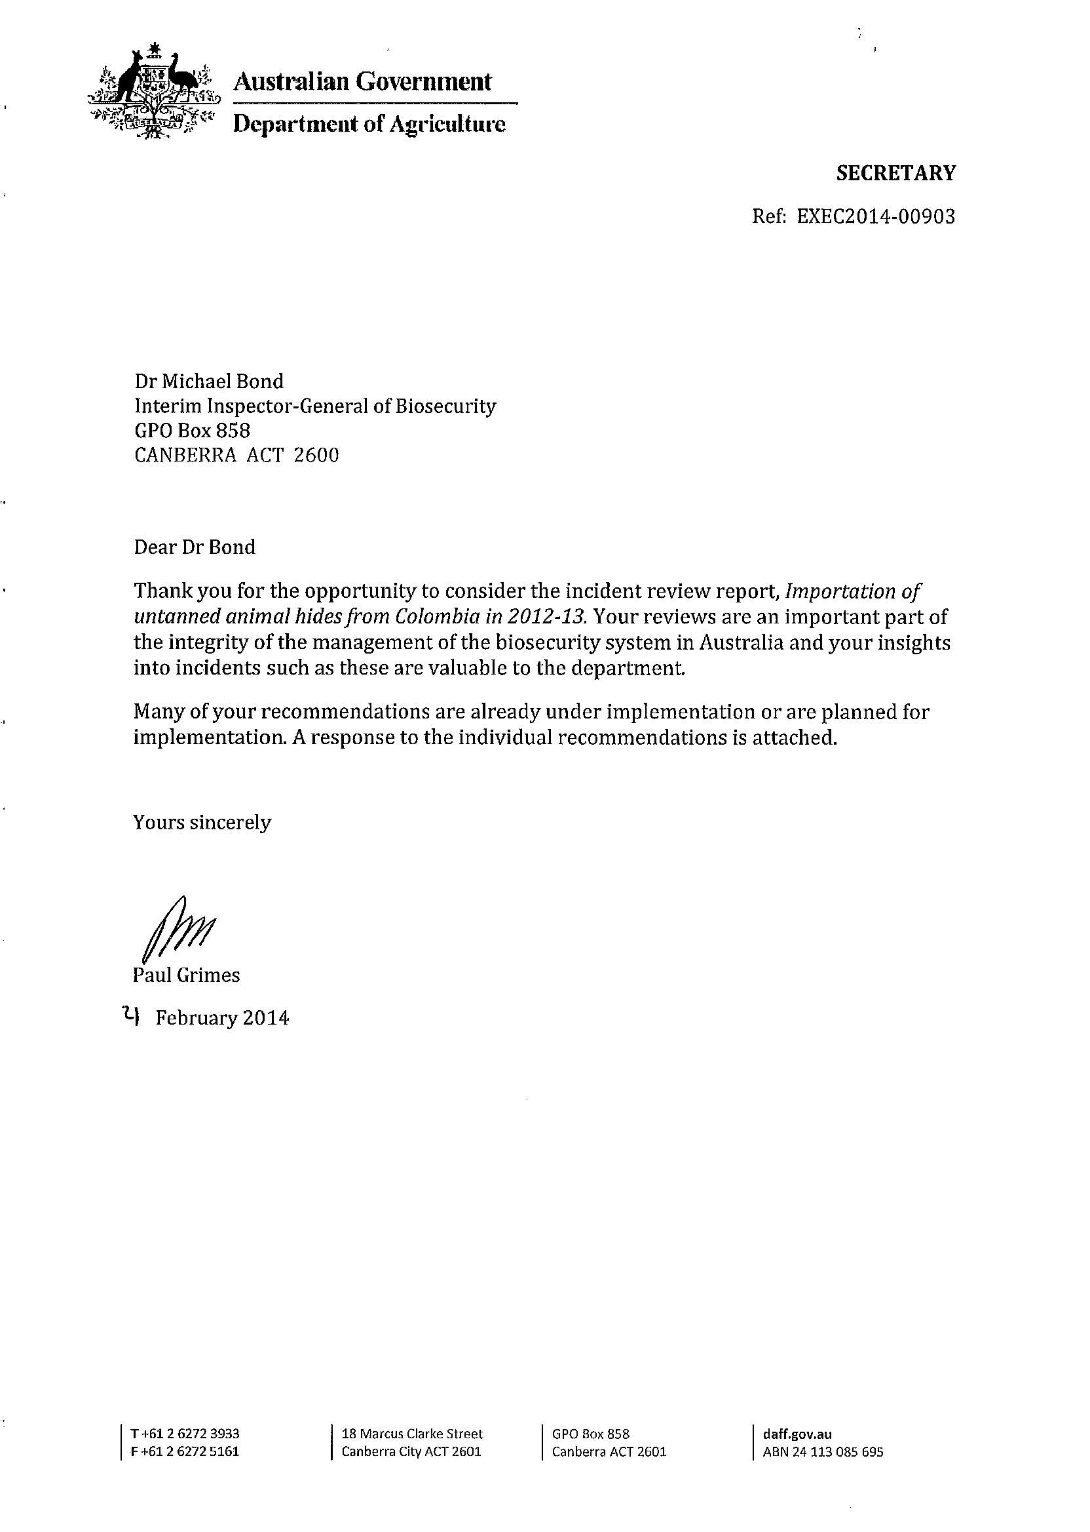
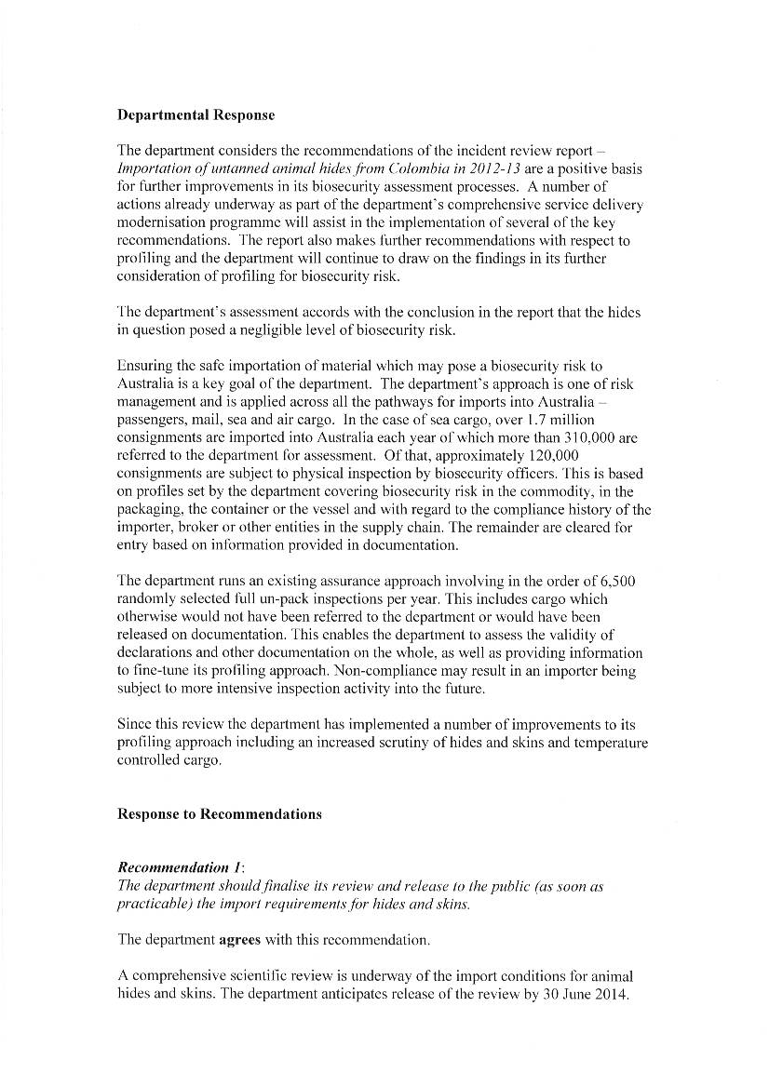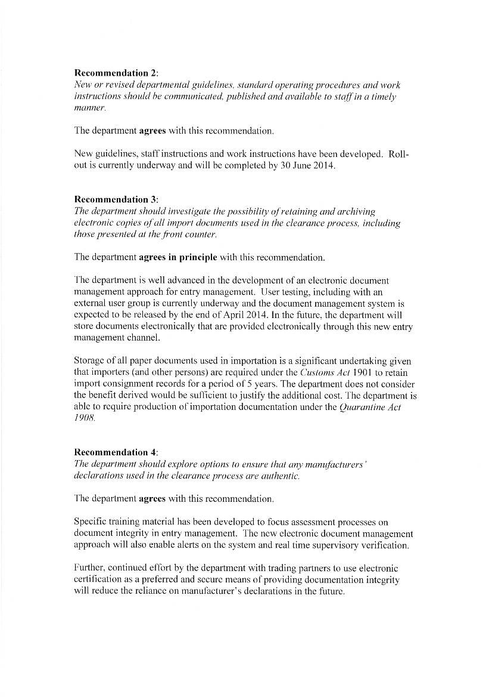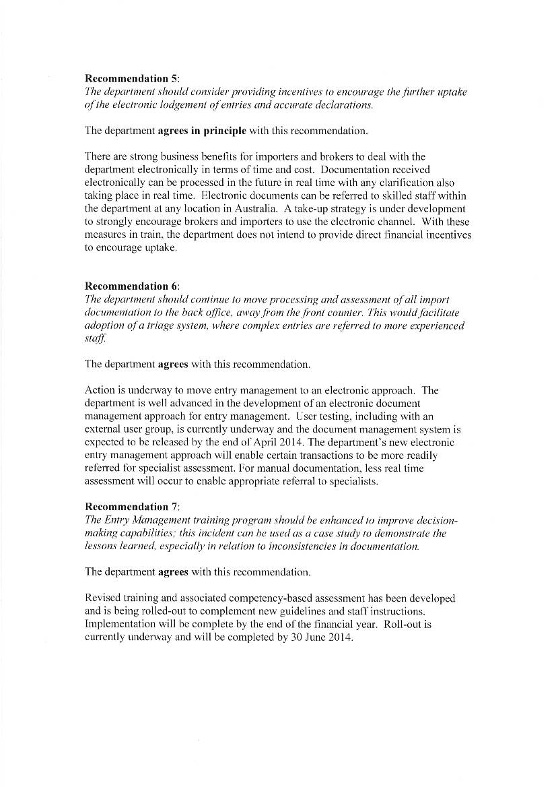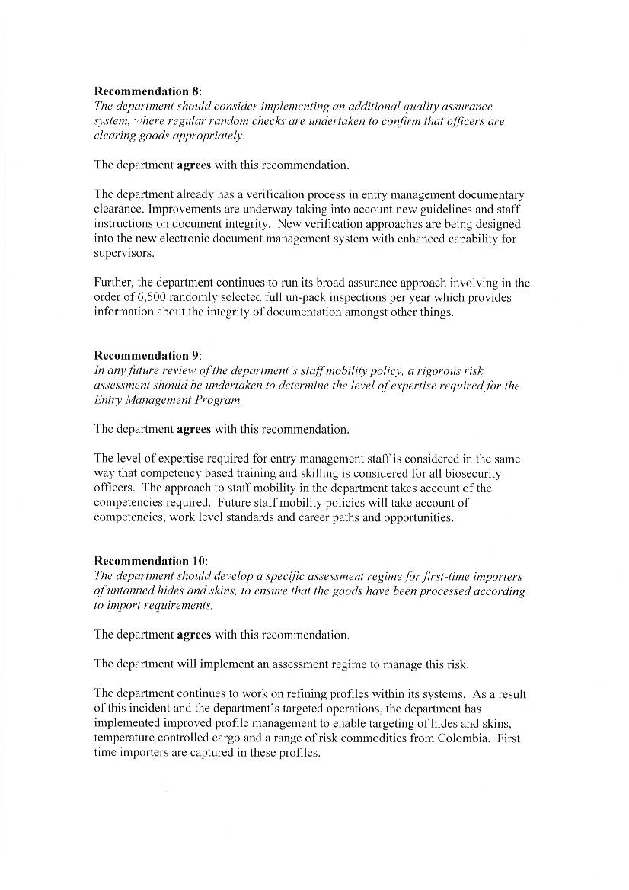

Appendix B: Conduct of the review
Role of the Interim Inspector-General of Biosecurity
As part of its preliminary response to the 2008 review of Australia’s quarantine and biosecurity arrangements (the Beale review), the Australian Government agreed to establish a statutory office of Inspector-General of Biosecurity. The role would be established under new biosecurity legislation currently being developed. In advance of this enabling legislation, interim administrative arrangements are in place.
On 1 July 2009 the government appointed an Interim Inspector-General of Biosecurity (IIGB). The scope of the role covers those systems and their risk management measures for which the Department of Agriculture (the department) is responsible.
The role also includes biosecurity measures relating to human health and environmental responsibilities undertaken by the department on behalf of the Department of Health and the Department of the Environment.
The IIGB works cooperatively with the department, other relevant Australian Government departments, competent authorities and organisations/companies involved in the biosecurity continuum.
The IIGB is independent from the organisational and functional arrangements of the department’s biosecurity-related divisions and reports to the Australian Government Minister for Agriculture.
IIGB reports are publicly available unless they contain confidential or sensitive information. IIGB reports do not name or specifically identify any person or organisation.
The Interim Inspector-General of Biosecurity’s program
The IIGB’s program of activities includes a comprehensive agenda of systems performance audits designed to provide assurance of biosecurity systems and risk management measures across Australia’s biosecurity continuum.
To compile the program, the IIGB considers potential audit/review topics from a variety of sources, including:
- consultation with the department and relevant industries
- outcomes of other relevant reviews/inquiries, such as the Australian National Audit Office and internal audits
- observations from previous IIGB audits
- expert advice
- media coverage.
The IIGB also considers the minister’s requests to undertake specified audits or reviews of the biosecurity system.
The IIGB prioritises audit/review topics. This includes an indicative qualitative risk assessment to assess the effects and likelihood of breakdowns in the biosecurity systems being audited.
The IIGB also:
- avoids duplication with other biosecurity-related assurance/audit activities
- balances effort and coverage across the biosecurity continuum and sectors
- balances effort and coverage of the elements of the risk management processes outlined in the ISO 31000:2009 standard.
The audit team
Auditors Ajay Singh and Cassandra Valentine assisted the IIGB to undertake this review.

Appendix C: Chronology of events
Date | Occurrence
16 May 2013 | The Department of Agriculture received information from a cold store owner (QAP 1) in Sydney about 20 bags of animal hides from Colombia that had been stored at the facility since September 2012. The cold store owner was concerned that the hides were not fully tanned.
16 May 2013 | The department ordered the consignment of hides at QAP 1 into quarantine.
20 May 2013 | The department requested the required documentation from the importer/broker in relation to the animal hides found at QAP 1.
23 May 2013 | The department records showed a further six consignments of animal hides imported from Colombia by the same importer/broker. The department requested documentation for the six consignments.
14 June 2013 | The importer/broker forwarded all the documentation via email to the department after close of business on Friday.
20 June 2013 | The department located four containers linked to the six consignments at another quarantine approved premises (QAP 2) in Sydney. Ten bags of non-containerised hides were also inspected at the site. All hides were ordered into quarantine.
25 June 2013 | The department inspected and accounted for 105 bags of hides at QAP 2. A total of 115 bags of hides were located at QAP 2, which included the ten bags of non-containerised hides were inspected at the site on the 20 June 2013.  Samples of the hides were inspected by a tanning expert who concluded that they were only limed and not fully tanned. A written report was provided to the department on 2 July 2013.
17 July 2013 | The department formally seized 135 of the 180 bags of animal hides that were reported as being imported—20 bags from QAP 1 and 115 bags from QAP 2.
19 July 2013 | The department moved the animal hides from QAP 1 to QAP 2. This consolidated all seized animal hides at one location.
26 July 2013 to 14 August 2013 | All 135 bags of seized hides were transported to an approved treatment provider in Sydney, pending incineration.
28 August 2013 | The department received notification that the 135 bags of seized hides had been destroyed (as directed by the department).

Appendix D: Photographs
These photographs of hides, bags, pallets and surrounding floor areas were taken in 2013 by the Interim Inspector-General of Biosecurity and department officers. The photographs were later examined by a forensic expert to comment on the level of biosecurity risk.
Photograph D1  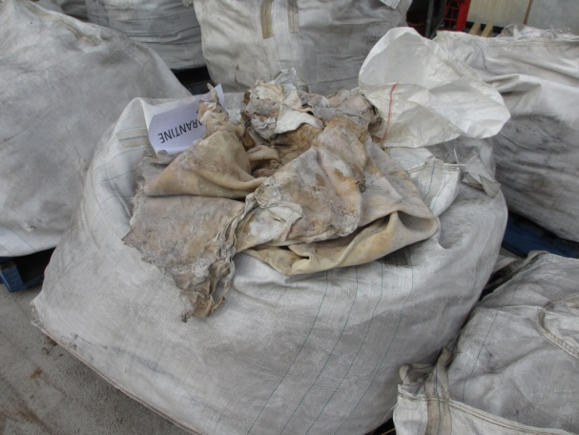  Hides at QAP 1  Source: Department of Agriculture, 2013 | Photograph D2  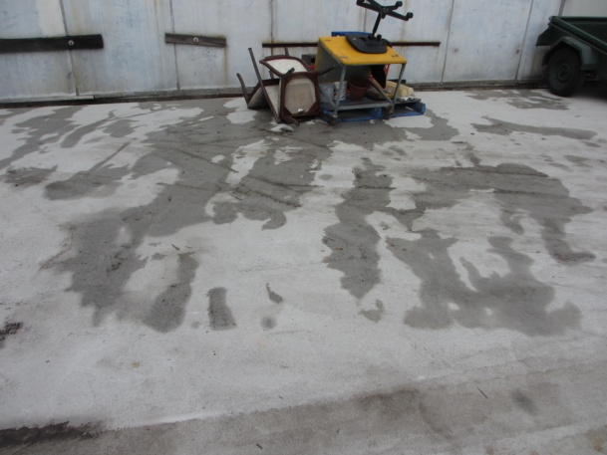  Evidence of condensate at QAP 1 caused by thawing of hides and any melting ice  Source: Department of Agriculture, 2013
Photograph D3  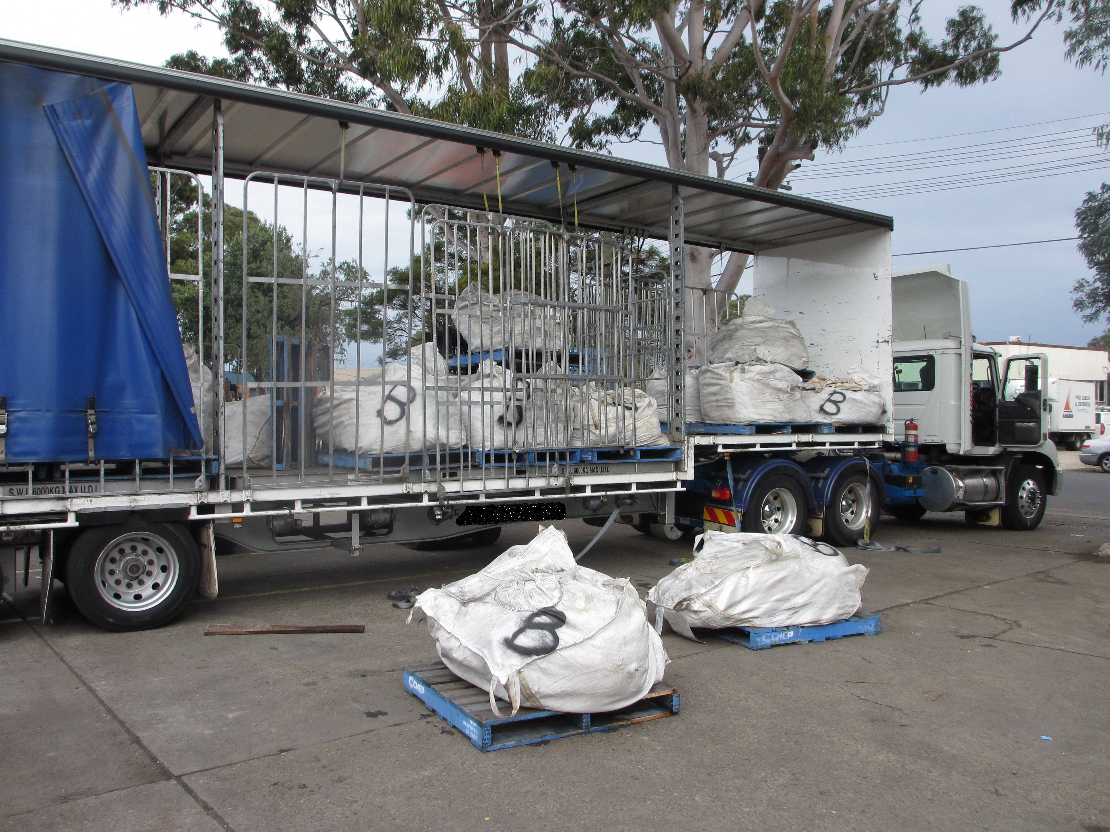  Tautliner truck at QAP 1  Source: Department of Agriculture, 2013 | Photograph D4  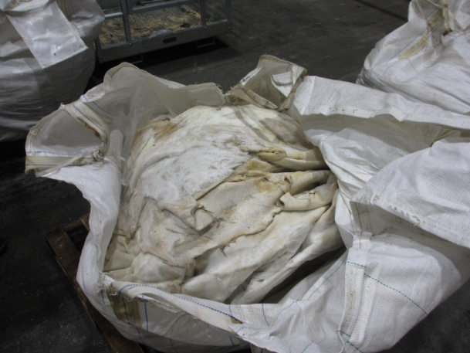  Hides at QAP 2  Source: Department of Agriculture, 2013

Photograph D5  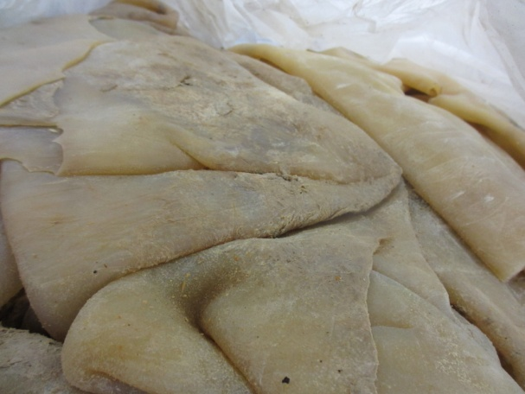  Hides at QAP 2  Source: Department of Agriculture, 2013 | Photograph D6  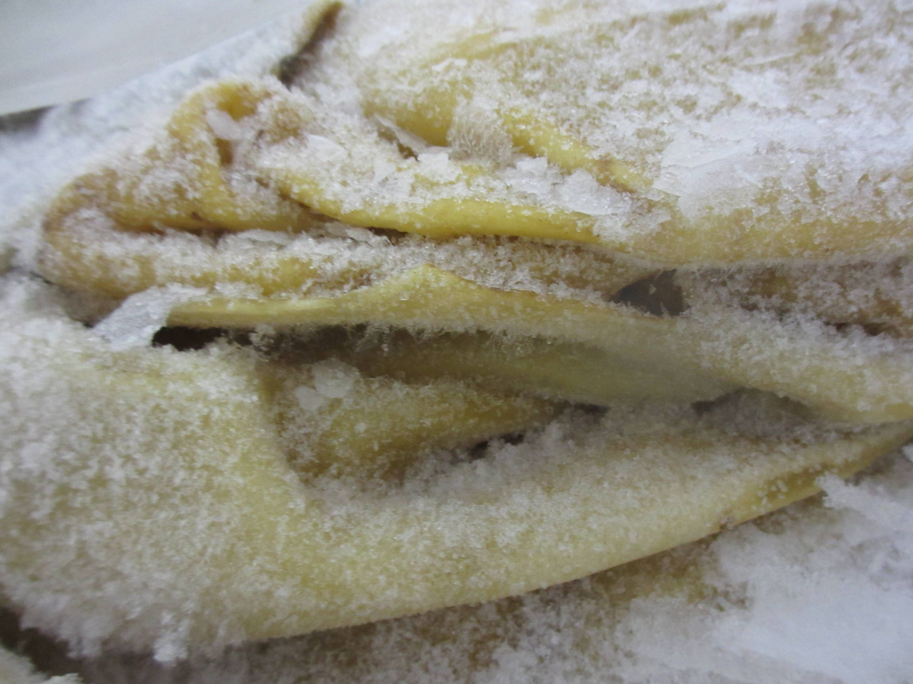  Showing ice on hides at QAP 2  Source: Department of Agriculture, 2013
Photograph D7  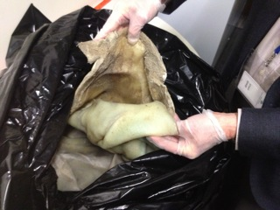  IIGB inspection of the hides at Central East Regional Office  Source: Interim Inspector-General of Biosecurity, 2013 | Photograph D8  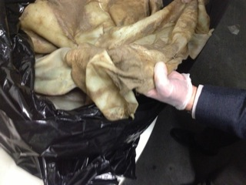  IIGB inspection of the hides at Central East Regional Office  Source: Interim Inspector-General of Biosecurity, 2013
Appendix E: Relevant Australian legislation
The Quarantine Act 1908 and its subordinate legislation, including the Quarantine Proclamation 1998, are the legislative basis of human, animal and plant biosecurity in Australia.
Some key provisions are set out below.
Quarantine Act: Scope
Subsection 4(1) of the Quarantine Act 1908 defines the scope of quarantine as follows.
In this Act, quarantine includes, but is not limited to, measures:
(a) for, or in relation to:
(i) the examination, exclusion, detention, observation, segregation, isolation, protection, treatment and regulation of vessels, installations, human beings, animals, plants or other goods or things; or
(ii) the seizure and destruction of animals, plants, or other goods or things; or
(iii) the destruction of premises comprising buildings or other structures when treatment of these premises is not practicable; and
(b) having as their object the prevention or control of the introduction, establishment or spread of diseases or pests that will or could cause significant damage to human beings, animals, plants, other aspects of the environment or economic activities.
Section 5D of the Quarantine Act 1908 covers the level of quarantine risk.
A reference in this Act to a level of quarantine risk is a reference to:
(a) the probability of:
(i) a disease or pest being introduced, established or spread in Australia or the Cocos Islands; and
(ii) the disease or pest causing harm to human beings, animals, plants, other aspects of the environment, or economic activities; and
(b) the probable extent of the harm.
Section 5D of the Quarantine Act 1908 includes harm to the environment as a component of the level of quarantine risk. Environment is defined in section 5 of the Quarantine Act 1908, in that it:
includes all aspects of the surroundings of human beings, whether natural surroundings or surroundings created by human beings themselves, and whether affecting them as individuals or in social groupings.
Quarantine Proclamation
The Quarantine Proclamation 1998 (the Proclamation) is made under the Quarantine Act 1908. It is the principal legal instrument used to control the importation into Australia of goods of quarantine (or biosecurity) interest. The Proclamation empowers a Director of Quarantine to grant a permit to import.
Section 70 of the Quarantine Proclamation 1998 sets out the matters to be considered when deciding whether to grant a permit to import:
In deciding whether to grant a permit to import a thing into Australia or the Cocos Islands, or for the removal of a thing from the Protected Zone or the Torres Strait Special Quarantine Zone to the rest of Australia, a Director of Quarantine:
(a) must consider the level of quarantine risk if the permit were granted; and
(b) must consider whether, if the permit were granted, the imposition of conditions on it would be necessary to limit the level of quarantine risk to one that is acceptably low; and
(ba) for a permit to import a seed of a kind of plant that was produced by genetic manipulation—must take into account any risk assessment prepared, and any decision made, in relation to the seed under the Gene Technology Act; and
(c) may take into account anything else that he or she knows that is relevant.
Section 38 of the Quarantine Proclamation 1998 sets out the legislation applicable to hides and skins:
Dead animals or animal parts the importation of which is prohibited other than subject to conditions (Quarantine Act 1908, ss 5(1) and 13(1)(d), (e) and (f))
(1) The importation into Australia of a dead animal or animal part (except an animal or part to which subsection (2) applies) is prohibited unless a Director of Quarantine has granted a permit to import the animal or part into Australia.
Note: For what a Director of Quarantine must consider when deciding whether to grant such a permit, see Part 8.
(2) This subsection applies to the following animals or animal parts:
(a) an animal or part that:
(i) is mentioned in an item in table 13; and
(ii) complies with any restriction or condition set out in the item;
(b) oysters in half shells from New Zealand, if the shells are clean and free of viable animals and plants;
(c) a fish product (other than a product of fish of the family Salmonidae or Plecoglossidae) that:
(i) is wholly or partly of teleost origin; and
(ii) is accompanied into Australia by the person importing it; and
(iii) is imported in an amount up to 5 kilograms; and
(iv) is eviscerated or is processed further than evisceration.
(2A) In this section and the table, animal part includes a product derived from or containing an animal or an animal part.
(4) For the table, an animal or part is non-viable if a living animal of the same species cannot be produced from it.
Table 13: Dead animals and animal parts (extract)
Column 1  Item | Column 2  Animal, article or part
Animals and animal parts
Skins and hides
5 | Animal (including fish) skins, if preserved or tanned
6 | Rawhide dog chews, if accompanied by a manufacturer’s declaration stating that the product has been soaked in a lime solution of pH 14 for not less than eight hours
6A | An article containing rawhide, if:  (a) it is intended for the personal use of the person seeking to import the article; and  (b) it is to be imported by itself or with no more than four other articles of the same kind; and  (c) it is treated on arrival, before release from quarantine, to limit the level of quarantine risk to one that is acceptably low

Appendix F: Agencies, groups and individuals consulted by the Interim Inspector-General of Biosecurity
The Interim Inspector-General of Biosecurity consulted and acknowledges the valuable assistance provided by the following agencies, groups and individuals:
- Animal Biosecurity Branch, Department of Agriculture—responsible for developing and maintaining biosecurity policy.
- Biological Import Program, Department of Agriculture—responsible for assessing import permits for biological material (animal products—excluding live animals).
- Industry Arrangements and Performance Branch, Department of Agriculture—sets policy and manages and coordinates standards and national delivery of third-party biosecurity arrangements in Australia and overseas, in consultation with industry. The branch provides
  - support for biosecurity service delivery activities that offer scientific advice
  - compliance and performance management services to import clearance operations nationally.
- Sydney regional office (Central East Region), Department of Agriculture—provides quarantine and biosecurity services for clearance of cargo, mail, vessels and passengers at the Australian border.
- QAP operators in Sydney—provide post-arrival quarantine services in QAP Class 2.5 (premises for receiving, storage and inspection of commodities that have temperature controlled storage requirements).
- Tanning experts (with extensive experience working in the tanning and leather industry) in Victoria and New South Wales.
- Forensic science expert in Canberra.
- Industry stakeholders.

References
DAFF 2012, Minimum document requirements policy, version 1.6, Department of Agriculture, Fisheries and Forestry, Canberra, October 2012.
Harkness, J 1991, Review of conditions applied to the import of hides and skins into New Zealand, New Zealand. National Agricultural Security Service Publication, vol. 91. no. 3, Ministry of Agriculture and Fisheries, Wellington, New Zealand, May 1991.
NZ IRA 2008, Import risk analysis: Hides and skins from specified animals, April 2008, Biosecurity New Zealand, Ministry of Agriculture and Forestry, Wellington, New Zealand.
OIE 2013a, Anthrax—general disease information sheet, World Organisation for Animal Health, Paris, oie.int/fileadmin/Home/eng/Media_Center/docs/pdf/Disease_cards/ANTHRAX-EN.pdf (pdf 314kb), accessed 6 December 2013.
—— 2013b, Foot & mouth disease—general disease information sheets, World Organisation for Animal Health, Paris, oie.int/fileadmin/Home/eng/Media_Center/docs/pdf/Disease_cards/FMD-EN.pdf (pdf 342kb), accessed 6 December 2013.
—— 2013c, Rinderpest—general disease information sheet, World Organisation for Animal Health, Paris, oie.int/fileadmin/Home/eng/Media_Center/docs/pdf/Disease_cards/RINDERPEST-EN.pdf (pdf 341kb), accessed 6 December 2013.

