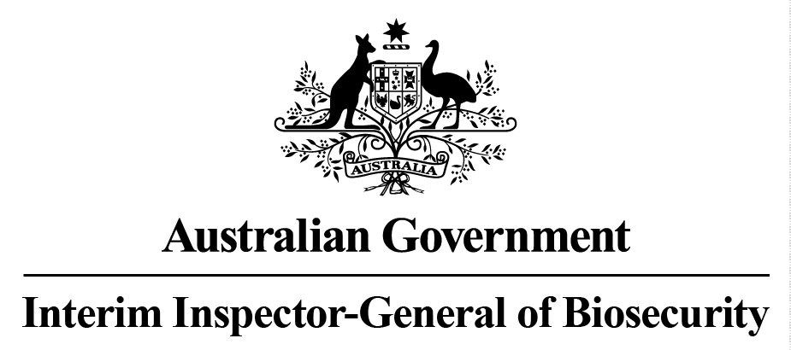

Horse imports - management of biosecurity risks July to December 2015
Audit report
No. 2015–16/06

© Commonwealth of Australia 2016
Ownership of intellectual property rights
Unless otherwise noted, copyright (and any other intellectual property rights, if any) in this publication is owned by the Commonwealth of Australia (referred to as the Commonwealth).
Creative Commons licence
All material in this publication is licensed under a Creative Commons Attribution 3.0 Australia Licence, save for content supplied by third parties, logos and the Commonwealth Coat of Arms.

Creative Commons Attribution 3.0 Australia Licence is a standard form licence agreement that allows you to copy, distribute, transmit and adapt this publication provided you attribute the work. A summary of the licence terms is available from creativecommons.org/licenses/by/3.0/au/deed.en. The full licence terms are available from creativecommons.org/licenses/by/3.0/au/legalcode.
Cataloguing data
Interim Inspector-General of Biosecurity 2016, Horse imports – management of biosecurity risks July to December 2015, Department of Agriculture and Water Resources, Canberra.

Internet
Horse imports – management of biosecurity risks July to December 2015 is available at igb.gov.au/Pages/completed-audits-and-reviews.aspx.

Interim Inspector-General of Biosecurity
Department of Agriculture and Water Resources
Postal address GPO Box 858 Canberra ACT 2601
Switchboard +61 2 6272 3933
Email inspgenbiosecurity@agriculture.gov.au
Web igb.gov.au/Pages/default.aspx
Inquiries about the licence and any use of this document should be sent to copyright@agriculture.gov.au.
The Australian Government, represented by the Interim Inspector-General of Biosecurity, has exercised due care and skill in preparing and compiling the information and data in this publication. Notwithstanding, the Interim Inspector-General of Biosecurity, Australian Government employees and advisers disclaim all liability, including for negligence and any loss, damage, injury, expense or cost incurred by any person as a result of accessing, using or relying on information or data in this publication to the maximum extent permitted by law.
Contents
1 Introduction 4
2 Background 4
3 Audit objective 4
4 Methodology 5
5 Findings 5
6 Conclusion 6
7 Next review cycle 6

- Introduction
  - In May 2014 the Interim Inspector-General of Biosecurity (IIGB) published a report ‘Arrangements for oversight of horse biosecurity risk management’. The report outlined the IIGB’s future commitment to an ongoing cycle of review and assessment of the biosecurity risk management controls used by the Department of Agriculture and Water Resources (the department) for importing horses to Australia.
  - As part of the IIGB’s 2015-16 work program, the IIGB undertook a desktop review of data and documentation relating to the import of horses to Australia during the period July to December 2015.
- Background
  - In July 2009, the Australian Government appointed an Interim Inspector-General of Biosecurity to enhance the integrity of Australia’s biosecurity systems through the independent evaluation and verification of the performance of these programs across the biosecurity continuum – pre-border, border and post-border.
  - The department allocates significant resources to the on-going monitoring and improvement of the management of biosecurity risks related to the importation of horses. Accordingly, the IIGB pays close attention to the biosecurity risks associated with the importation of horses to Australia, as part of the IIGB’s broader annual work program.

Process for importing horses to Australia
  - Australian biosecurity import conditions allow the import of horses from approved countries that meet strict conditions.
  - A valid import permit from the department is required to import a horse. The import permit lists all the import conditions that the horse must meet in order to be eligible for import to Australia.
  - Prior to import, horses spend at least 14 days in pre-export isolation in the exporting country. During this pre-export quarantine period, the health of the horse is monitored and the animal is tested for diseases of biosecurity concern.
  - Once testing is complete, and if all import conditions have been met, the horse is given permission to be imported to Australia.
- Audit objective
  - The objective of this desktop review was to assess the approval processes for:
    - offshore pre-export quarantine (PEQ) premises used for the export of horses to Australia that were approved by the department during the period July to December 2015
    - onshore post-arrival quarantine (PAQ) premises used for the import of horses to Australia that were approved by the department during the period July to December 2015.
- Methodology
  - For the period July to December 2015, the IIGB reviewed:
    - horse import numbers including individual horse details, import permits, PEQ and PAQ facilities used for each animal
    - the approval status for each PEQ premises in exporting countries, including information on all approved, expired and new applications
    - any PEQ or PAQ facility audit reports and associated documents prepared by the department during the three months prior to the review period
    - details of any biosecurity incidents, including response procedures, reported to the department in the three months prior to the review period.
- Findings

Offshore PEQ facilities approved for exporting horses to Australia
  - For this review period, the IIGB notes that as at 1 July 2015 there were 23 offshore PEQ facilities approved by the department for exporting horses to Australia.
  - The IIGB notes that between July and December 2015, the department conducted on-site audits to approve or re-approve three offshore PEQ facilities and one PAQ facility.
  - The IIGB assessed the approval processes for these three PEQ facilities and the single PAQ facility. The IIGB has no concerns with the approvals granted for these facilities.

Number of horses imported to Australia January to June 2015
  - The IIGB notes that for the period 28 July 2015 to28 December, import permits were processed for 259 horses to be imported into Australia through 14 offshore PEQ facilities.
- Conclusion
  - As a result of the IIGB’s previous review of horse imports for the period January to June 2015, the IIGB’s undertook to consider what biosecurity concerns, if any, may have emerged as a result of the decentralisation of the department’s service delivery operations relating to the importation of horses into Australia.
  - As mentioned previously the IIGB notes that, as with any new program or significant change in responsibilities, there are potential adverse effects that might impact on the level of national biosecurity risk and these impacts might not be immediately apparent.
  - The IIGB has conducted this review with those changes in mind and considers the department’s biosecurity risk management procedures for importing horses to Australia appear to be satisfactory.
  - No recommendations have been raised as part of this review.
- Next review cycle
  - The IIGB notes that the timing and scope of future reviews of the department’s management of horse imports will be considered as part of the development of the Inspector-General of Biosecurity’s 2016-17 work program.

Dr Michael Bond
Interim Inspector-General of Biosecurity
15 March 2016

